G-EHMM DR400R Operating Notes
The arrival of G-EHMM is to provide a replacement for CC, which is now on a longer-term repair after its recent mid-air collision. MM has received engine, propeller and exhaust system from CC.
The aircraft is most like CC. They are of similar vintage and the differences are as follows:
The seating and forward view; Quite like CC with a high seating position giving a “flat” appearance during climb. The seat adjuster in under the front of the seat and swings right to unlock and left to lock. The seat back is short with a standard 4 point harness.
Rudder requirements; A noticeable right pedal force required during climb, nothing in descent. On the ground you will notice a snatching when you apply more than half rudder pedal, this can be managed with a little practice. This is similar to YM.
Engine; The engine is the one previously installed in CC. It has a slightly “lumpy” nature at around 1000-1200rpm, this is acceptable and runs smoothly at higher power settings. Static rpm is 2420 rpm which increases to 2500 rpm at normal tow speed. The RPM indicator is unusually located in the top centre of the instrument panel.
Trim position; The trim position, again similar to CC with no actual graduation. T/O and Landing position equivalent to 5.5 units is marked and is approximately mid position, descent position is equivalent to 3 units and has also been marked.
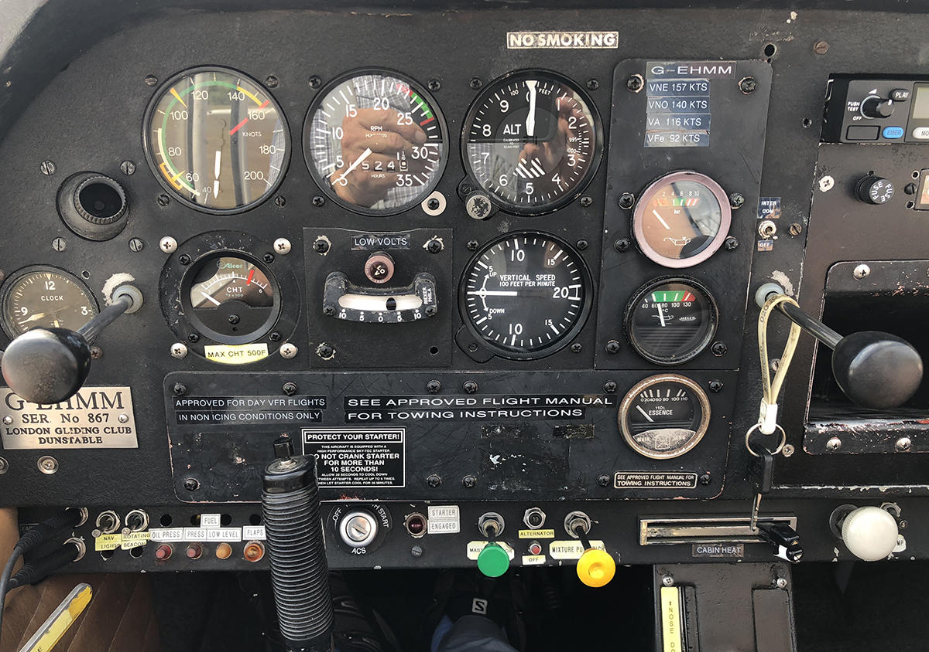
Instruments; see picture
ASI is correctly marked except for the descent pointer which is on 110 kts, whereas with the four-blade propeller fitted, the descent speed is 100 kts.
RPM gauge is fitted in the top centre and is correct apart from a red “no go” band which is not applicable to the engine/propeller combination we have.
Oil pressure gauge is in BAR with a correct green band. So 4.4-6.2 BAR is the “normal” operating range but may go down to 1.8 BAR (25psi) whilst idling.
CHT gauge can be found under the ASI, it is marked in Fahrenheit. Max is 500F, with 400F being “normal”.
Switches;
The Master switch is a plunger type like that fitted to YM.
The starter is a key operated starter like that fitted in CA.
Strobe light is operated by a switch marked ‘Rotating Beacon’ on the left side of the lower panel.
Landing and Taxi lights are LEDs located on left and right wing respectively. They are operated by quick release circuit breakers located on the right lower panel.
The parameter card is situated on the front panel;
Speeds are standard, with the descent speed of 100 kts requiring 2200 rpm.

We will endeavour to correct instrument markings in due course along with providing a reference on the website.

Robin May
30.7.18

